**Name : Adwait Purao**

**UID : 2021300101**

**Class : TE Comps B**

***Service Innovation : Google***



**Introduction:** Google, the technology behemoth, has continuously pushed the boundaries of innovation, transcending its origins as a search engine. Through its relentless pursuit of new ideas and cutting-edge technologies, Google has introduced a myriad of services that have transformed the way we interact with information, communicate, and navigate our digital lives.

**Key Phases:** Google's journey of service innovation can be categorized into several key phases, each marked by groundbreaking introductions and strategic pivots:

1. Search Engine Supremacy (1998-2004): Google's initial focus was on revolutionizing web search through its innovative PageRank algorithm and minimalist design approach. This phase cemented Google's dominance as the world's leading search engine, becoming an essential part of the internet experience.
2. Diversification and Acquisitions (2005-2010): With a solid foundation in search, Google embarked on a diversification strategy, venturing into adjacent domains such as online advertising (AdWords, AdSense), productivity tools (Gmail, Google Docs), and mobile operating systems (Android). This phase was marked by strategic acquisitions and the development of new products and services to expand Google's ecosystem.
3. Expansion into Cloud and AI (2011-2015): Recognizing the potential of cloud computing and artificial intelligence, Google made significant investments in these areas. Services like Google Cloud Platform and Google Cloud AI were introduced, positioning Google as a leader in cloud infrastructure and machine learning capabilities.
4. Moonshot Innovations (2016-2020): During this phase, Google pursued audacious "moonshot" projects through its subsidiary, X (formerly Google X). Initiatives like self-driving cars (Waymo), internet-beaming balloons (Loon), and cutting-edge healthcare technologies (Verily) exemplified Google's commitment to solving complex global challenges through disruptive innovations.
5. Enhancing User Experiences (2021-present): In recent years, Google has focused on enhancing user experiences across its various services. The introduction of products like Google Lens (visual search), Google Assistant (virtual assistant), and Google Stadia (cloud gaming platform) demonstrates Google's efforts to create seamless and intuitive experiences for users in multiple domains.

***Google Maps***

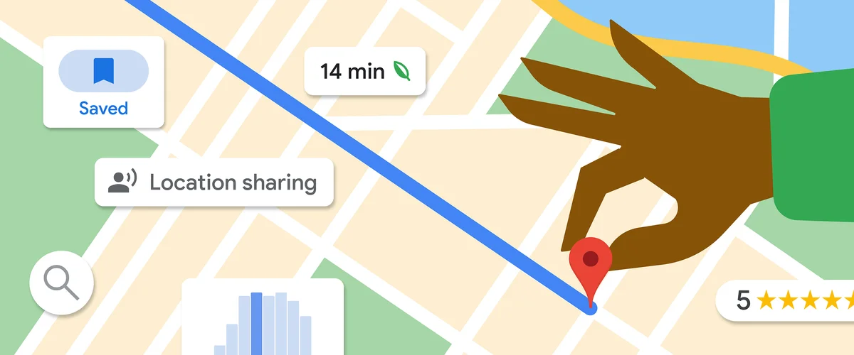

**Introduction:** Google Maps, launched in 2005, has revolutionized the way we navigate and explore the world around us. This pioneering mapping service, developed by Google, has become an indispensable tool for millions of users worldwide, providing comprehensive and accurate maps, along with a myriad of features that enhance our daily lives.

**Key Features of Google Maps:**

1. Detailed Mapping and Navigation: At its core, Google Maps offers detailed and up-to-date maps of cities, countries, and regions across the globe. Users can easily search for locations, get turn-by-turn directions for driving, walking, or public transportation, and even view real-time traffic conditions.
2. Street View: One of the most innovative features of Google Maps is Street View, which provides panoramic street-level imagery. This feature allows users to virtually explore locations as if they were there, offering a unique perspective and aiding in trip planning.
3. Satellite and Terrain Imagery: Google Maps integrates high-resolution satellite imagery and terrain data, enabling users to visualize landscapes, buildings, and natural features from above. This feature is particularly useful for outdoor activities, such as hiking or exploring remote areas.
4. Local Business Information: Google Maps seamlessly integrates information about local businesses, including contact details, opening hours, user reviews, and even indoor maps for certain locations. This feature enhances the overall user experience by providing valuable context and information about nearby services and amenities.
5. Real-Time Updates: Google Maps leverages real-time data and user contributions to provide up-to-date information about road closures, construction zones, and traffic conditions. This feature helps users plan their routes more efficiently and avoid potential delays.
6. Offline Maps: Google Maps offers the ability to download and cache maps for specific regions, allowing users to navigate and access basic map data even without an internet connection. This feature is particularly useful for travelers or those in areas with limited connectivity.
7. Integration with Other Google Services: Google Maps seamlessly integrates with other Google services, such as Google Search, Google Photos, and Google Assistant, providing a cohesive and interconnected experience for users across various platforms and devices.

***Google Lens***



**Introduction:** Google Lens, introduced in 2017, is a groundbreaking visual search tool that leverages Google's expertise in artificial intelligence and computer vision. This innovative service allows users to seamlessly interact with the physical world by simply pointing their smartphone camera at objects, landmarks, or even text, unlocking a wealth of information and capabilities.

**Key Features of Google Lens:**

1. Object Recognition: Google Lens uses advanced machine learning algorithms to recognize and identify a wide range of objects, from plants and animals to products, artwork, and more. This feature provides users with relevant information, such as product details, reviews, and purchase options, directly from their smartphone camera.
2. Text Recognition and Translation: One of the most powerful features of Google Lens is its ability to recognize and extract text from images. Users can point their camera at signs, menus, or documents, and Google Lens will automatically detect and translate the text into their preferred language, making it easier to navigate and understand foreign environments.
3. Landmark and Building Identification: Google Lens can identify famous landmarks, buildings, and architectural structures, providing users with historical information, interesting facts, and even virtual tours or augmented reality experiences related to the identified location.
4. Shopping and Product Search: When pointed at a product or item, Google Lens can identify it and provide users with shopping options, prices, and product details, making it easier to research and purchase items directly from the real world.
5. Optical Character Recognition (OCR): Google Lens incorporates OCR technology, allowing users to easily digitize text from physical documents, business cards, or handwritten notes, making it a valuable tool for productivity and organization.
6. Integration with Other Google Services: Google Lens seamlessly integrates with other Google services, such as Google Maps, Google Photos, and Google Assistant, providing a cohesive and interconnected experience for users across various platforms and devices.
7. Augmented Reality (AR) Experiences: Google Lens offers augmented reality experiences that overlay digital information onto the real-world environment, enabling users to interact with virtual objects, browse 3D models, or visualize furniture and home decor in their actual living spaces.

Google Lens exemplifies Google's commitment to pushing the boundaries of artificial intelligence and computer vision, enabling users to bridge the gap between the physical and digital worlds. With its constantly evolving capabilities, Google Lens promises to enhance our understanding and interactions with the world around us in new and innovative ways.

**Conclusion:** Google's journey of service innovation has been marked by groundbreaking introductions like Google Maps and Google Lens that have transformed how we interact with the world. Google Maps revolutionized navigation with features like detailed mapping, turn-by-turn directions, Street View imagery, and real-time traffic updates. Google Lens, leveraging AI and computer vision, enables seamless object recognition, text extraction, translation, landmark identification, and augmented reality experiences - bridging the physical and digital realms. Through these innovative services, Google exemplifies its pursuit of technology breakthroughs, enhancing user experiences across search, cloud computing, AI, and creating seamless, intuitive solutions that push the boundaries of what's possible.